***F NegroAmaro***

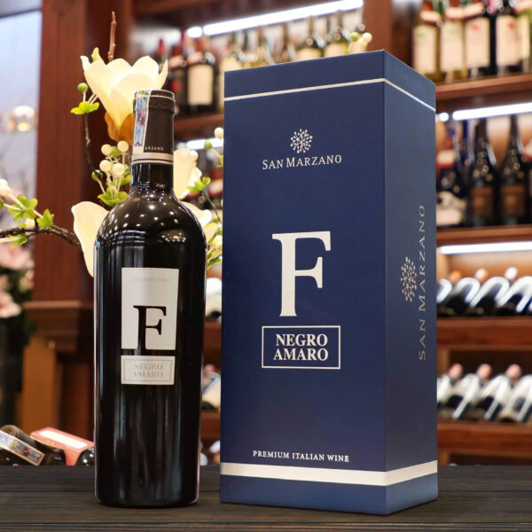

*"F NegroAmaro - Italian red, very full and deep purple, rich and complex in aromas with soft, spongy tannins and flavors of vanilla, ripe plums, purple myrtle, marmalade. The wine is quite thick, full of flavor in the mouth, round, soft and harmonious, rich in tannins, greasy with subtle buttery and cream flavors, mixed with the aroma of passionate cocoa and seductive cedar. It spreads in the mouth and is pleasantly smooth with a sweet and delicate finish.  
  
Grapes are hand-picked, picked early in the morning, selecting the best bunches of grapes. At the winery, the selection will again be made to select the best grapes to make the F."*